ATWOOD ORCHARD

Gravenstein: #1 on map. Introduced from Denmark 1669 – tart - sauce and cider.
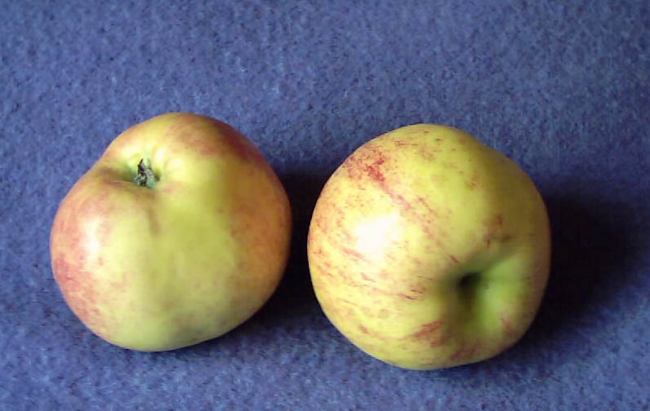

Yellow Transparent: #2 on map. Latvia 1850 – sharp taste - cooking. 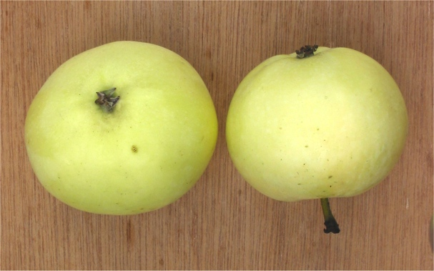

Unidentified: #3 on map

Baldwin: #7 on map. Massachusetts 1740 - cider, pie.

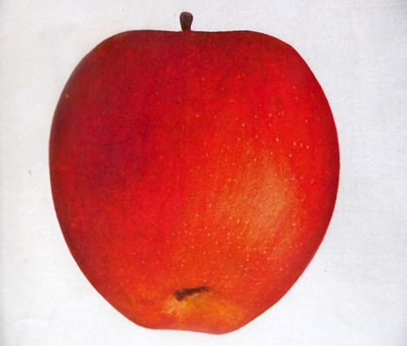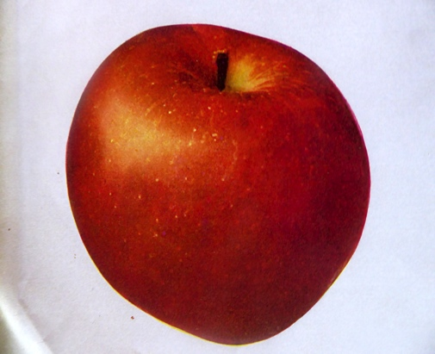

Mcintosh: #8 and #15 on map. Canada 1811 – tart - all purpose.

Unidentified: #11 on map

Sheepnose: #12 on map. Southern New England 18th century – rich, sweet – eating. This name has been applied to several cultivars having a conical shape including the Gilliflower #5 above.

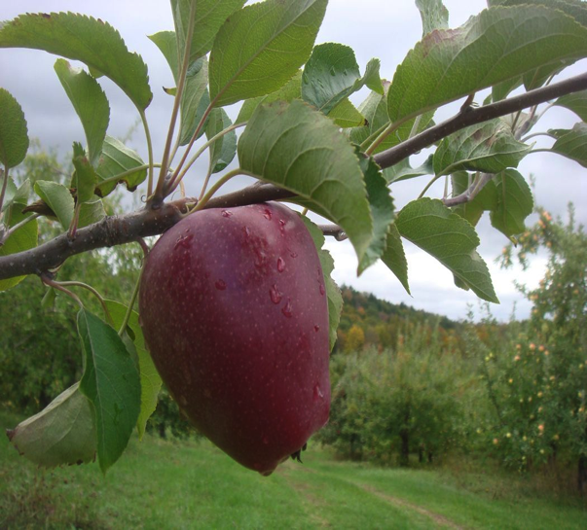

Gilliflower:#13 on

Russet: #4 on map. A group, not a single cultivar, e.g. Roxbury Russet, Golden Russett, etc.
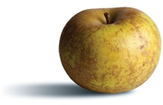

Gilliflower: #5 and #13 on map. American (CT) late 1700’s - dessert apple
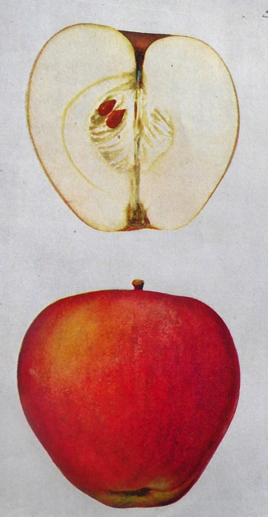

Red Astrachan: #9 on map. Russia early 1800’s – tart, crisp - eating, cooking, cider.

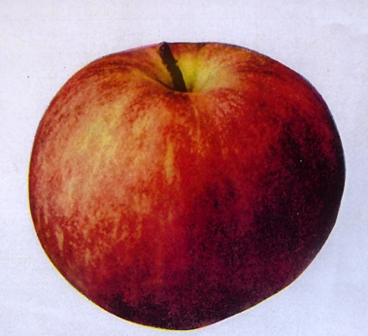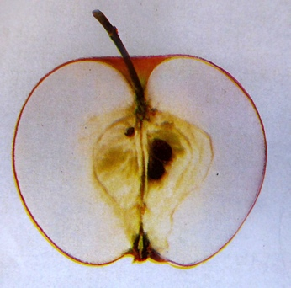

Stayman Winesap: #10 on map. Kansas 1866 – large, firm – eating, cider.

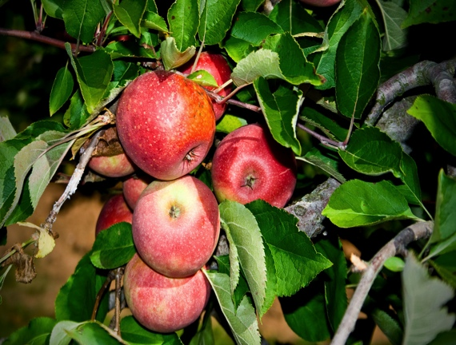

Streaked Pippin: #14 on map. Pippin cultivars colonial from New York – cooking, cider.

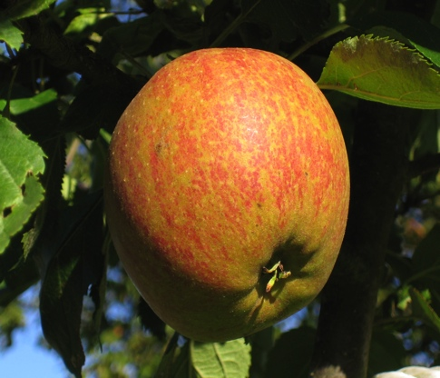

Mcintosh: #15 on map see #8 on map

Unidentified: #16 on map

Pearmain: #17 on map. Many cultivars UK – sweet – eating, stewing. In the early 20th century there were 24 different cultivars with Pearmain in their names.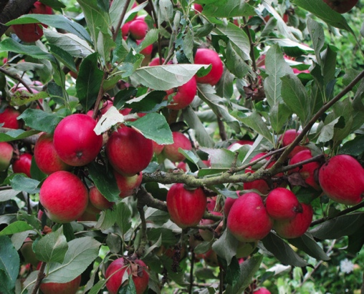

Northern Spy: #18 on map. New York 1840’s - tart, hard – pie, cider
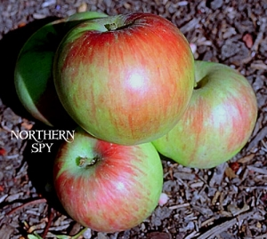

Unidentified: #19 on map

Lady: #20 on map. Introduced 1800’s – small - decorative, canning.

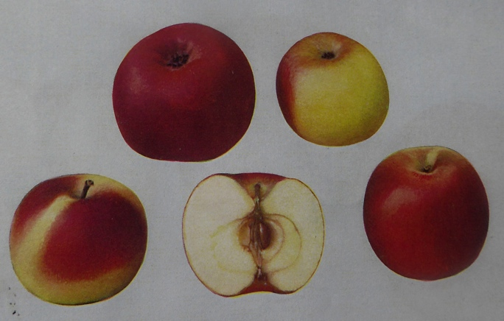

Unidentified: #21 on map

ATWOOD ORCHARD MAP

22
20
19
13
1!Unexpected End of Formula
5
9

18
16

21
4
8
1222
17

3
7
11

23
14
10
15
2

Jonathan: #22 on map. New York 1826 – sweet

